Ideation Phase
Brainstorm & Idea Prioritization Template

Date | 24 June 2026
Team ID | LTVIP2026TMIDS88789
Project Name | Smart Sorting: Identifying Rotten Fruits and Vegetables Using Transfer Learning
Maximum Marks | 4 Marks

Brainstorm & Idea Prioritization Template:
Step-1: Team Gathering, Collaboration and Select the Problem Statement
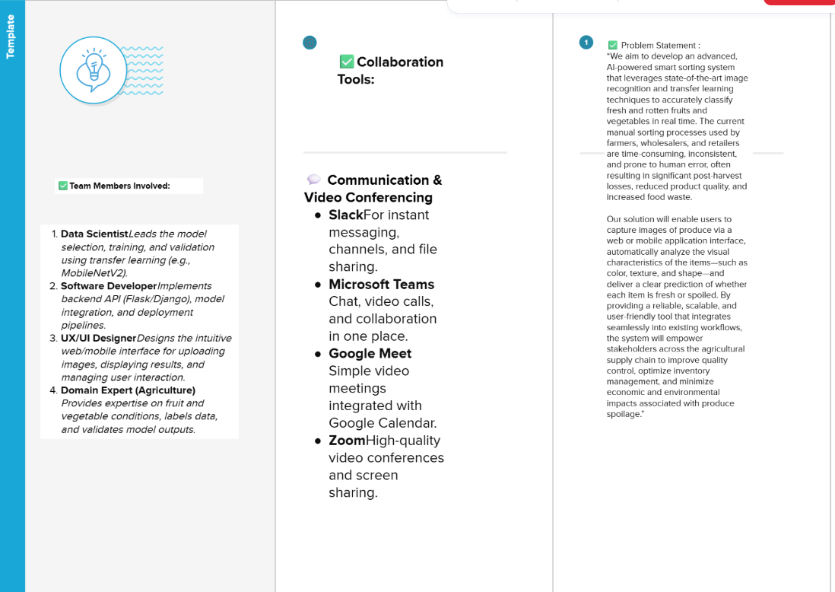

Step-2: Brainstorm, Idea Listing and Gro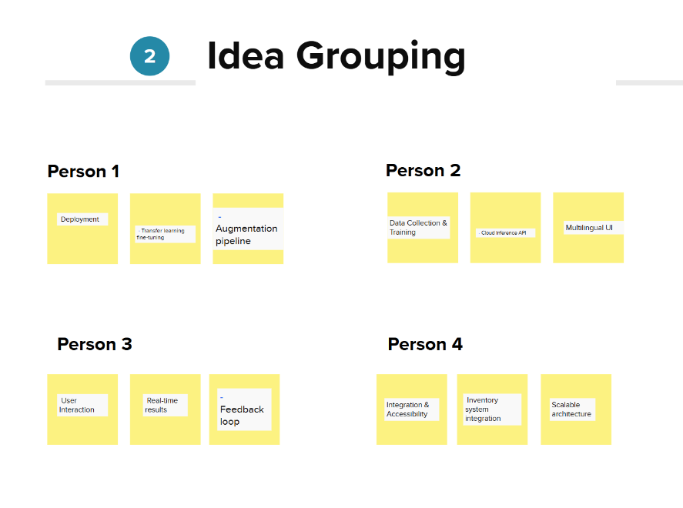
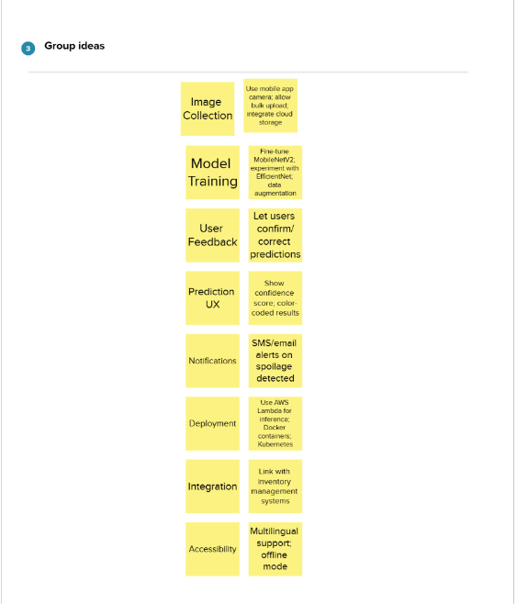

Step-3: Idea Prioritization
